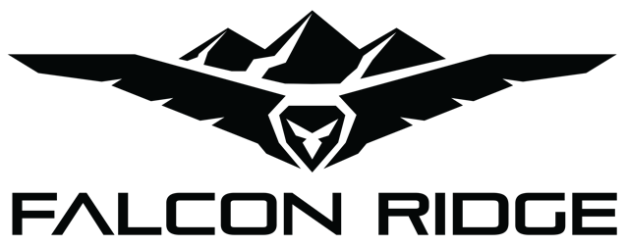
2515 Bypass Rd. Flemingsburg, KY 41041
606-845-7439

Polaris Ranger 150 Diamond Plate Aluminum Roof
PO-150-HT01 and HT02 / 53-10020

- Check over the parts included in the carton with the parts list shown below:

1 1/2” Loom Clamp (FR-10047) 6 each
1” Bolts (FR-10037) 6 each
Large Rubber Washers (FR-10087) 6 each
Large Stainless Washers (FR-10045) 6 each
Small Washers (FR-10044) 6 each
Locknuts (FR-10043) 6 each
140" Rubber Edge Trim (FR-10114) 1 each

If any parts are damaged or missing please contact customer service at (606) 845-7439.

- Begin by installing the rubber edge trim around the roof. You may need to cut it trim to fit properly.

- Place the top on the vehicle and proceed to clamp it to the roll cage. The front of the roof has beveled corner while the rear has rounded corners. Use the six 1 1/2” clamps to attach the top. The 1” Bolts will run down through the top and then through the clamp. The diagram below shows how to install clamps.
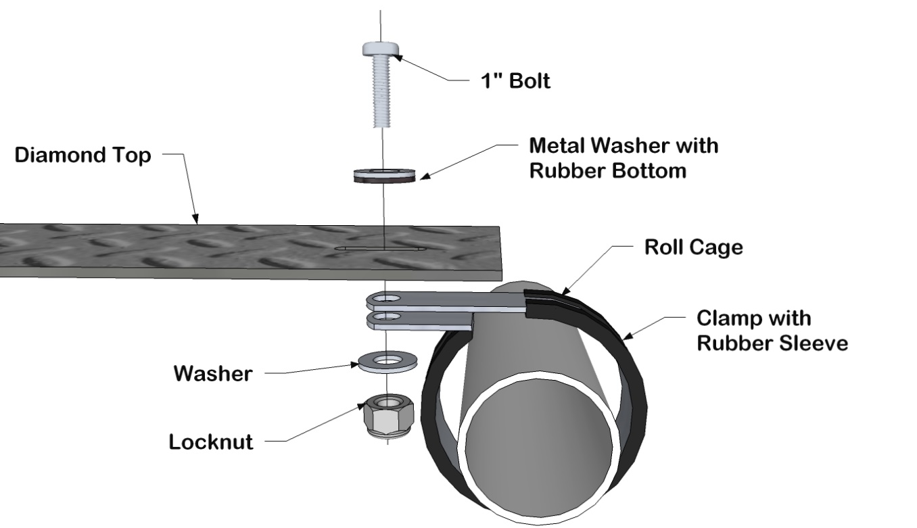

Thank you for your purchase!
Return Policy

If for any reason you choose to return this product it must be returned within 30 days from date item is received. You MUST package the product exactly as it was originally packaged from the factory to get a full refund for the product!
The vinyl windows should never be folded when packaging in the box or for storage purposes. Lay all the windows on top of each other with the canvas folded in between and the paper (if available) on both sides of the windows.
All returned products will be inspected upon arrival at the production facility and must be in unused, factory new condition to receive refund - a 25% restocking fee will apply.
If ordered from Falcon Ridge please call at 606-845-7439 to gain a return authorization number, use our preferred shipping carrier (UPS) to return the item (unless the item is defective, you are responsible for paying the shipping to return the item.) Any returns submitted to Falcon Ridge without a return authorization number will be charged a 20% restocking fee. If ordered from one of Falcon Ridge’s many distributors, you must first call them and see what their return policy is. Once your item reaches our production facility, our customer satisfaction team will inspect your item to ensure unused, factory new condition. NOTE: All windshields must be returned with the original protective film intact and not removed. Do NOT REMOVE if you have any intentions of returning the item. Refund/ replacement of a windshield will only be processed on items with original protective film or if the windshield is defective.
Items must be properly packaged in the original shipping carton to protect them during transit and ensure your returned item arrives back factory fresh, and in new resalable condition (any returned items that have been used, altered or damaged in any way will not be subject for a refund.) All contents including instruction manuals, accessories, hardware, Velcro, etc. must be included in your return shipment. Only items in OEM factory new condition will be approved. Once returned items are received, credit will be issued to the original credit card/ payment method used for the purchase. Outbound shipping and return shipping cost will not be refunded. Please allow 4 to 6 weeks for your refund to be processed.

Warranty

To The Owner of this Product:

Thank you for purchasing one of Falcon Ridge’s Cab Enclosures, Tops &/or Windshields! Below are the terms under which your product is covered under our manufacturer’s warranty.

30 Day Warranty which includes and is not limited to replacing the enclosure, tops and/or windshield due to defect of the product. Please refer to the return policy in this case for more information.

1 Year Warranty includes any defect in material or workmanship within this time frame we will gladly correct the problem or replace the enclosure, tops &/or windshield. Upon submitting for the correction or replacement we will need to receive pictures of the defect in material or workmanship along with the receipt from the date of purchase.

